Question 9 – Banking Transaction Analysis
A bank provides Customer, Account, Transaction, Loan, and Branch datasets. Analyze transaction patterns, customer groups, loan information, branch performance, and monthly transaction trends. Identify unusual transactions, correlations, outliers, and important financial insights.
import pandas as pd
import numpy as np
import matplotlib.pyplot as plt

# 1. DATA IMPORTING
customer = pd.read_csv("Customer.csv")
account = pd.read_csv("Account.csv")
transaction = pd.read_csv("Transaction.csv")
loan = pd.read_csv("Loan.csv")
branch = pd.read_csv("Branch.csv")

print("BANKING TRANSACTION ANALYSIS")
print("=" * 50)

# 2. DATASET DESCRIPTION & EXPLORATION
for name, df in {
"Customer": customer,
"Account": account,
"Transaction": transaction,
"Loan": loan,
"Branch": branch
}.items():
print("\n", name)
print("Shape:", df.shape)
print("Columns:", list(df.columns))
print("Missing values:", df.isnull().sum().sum())
print(df.head(3))

# Convert dates
transaction["Transaction_Date"] = pd.to_datetime(transaction["Transaction_Date"])
account["Open_Date"] = pd.to_datetime(account["Open_Date"])
loan["Loan_Start_Date"] = pd.to_datetime(loan["Loan_Start_Date"])

# 3. JOINING MULTIPLE DATASETS
data = transaction.merge(account, on="Account_ID") \
.merge(customer, on="Customer_ID") \
.merge(branch, on="Branch_ID")

print("\nJoined data shape:", data.shape)

# 4. GROUPING & AGGREGATION
print("\nTransaction Type Summary")
print(transaction.groupby("Transaction_Type")["Amount"].agg(
["count", "sum", "mean"]).sort_values("sum", ascending=False))

branch_summary = data.groupby("Branch_Name")["Amount"].agg(
["count", "sum"]).sort_values("sum", ascending=False)

print("\nBranch Performance")
print(branch_summary)

# 5. DATA SEGMENTATION
customer["Income_Group"] = pd.cut(
customer["Income"],
bins=[0, 30000, 60000, 100000, np.inf],
labels=["Low", "Medium", "High", "Very High"]
)

print("\nCustomer Income Segments")
print(customer["Income_Group"].value_counts())

# 6. CORRELATION ANALYSIS
corr = data[["Age", "Income", "Balance", "Amount"]].corr()

print("\nCorrelation Matrix")
print(corr)

plt.figure(figsize=(7, 5))
plt.imshow(corr, cmap="coolwarm")
plt.colorbar()
plt.xticks(range(4), corr.columns, rotation=45)
plt.yticks(range(4), corr.columns)
for i in range(4):
for j in range(4):
plt.text(j, i, f"{corr.iloc[i,j]:.2f}", ha="center")
plt.title("Correlation Heatmap")
plt.tight_layout()
plt.savefig("correlation_heatmap.png", dpi=200)
plt.show()

# 7. OUTLIER DETECTION - IQR METHOD
Q1 = transaction["Amount"].quantile(0.25)
Q3 = transaction["Amount"].quantile(0.75)
IQR = Q3 - Q1
upper = Q3 + 1.5 * IQR

outliers = transaction[transaction["Amount"] > upper]

print("\nTransaction Outliers:", len(outliers))
print(outliers[["Transaction_ID", "Amount", "Transaction_Type"]].head())

plt.figure(figsize=(7, 5))
plt.boxplot(transaction["Amount"])
plt.title("Transaction Amount - Outlier Detection")
plt.ylabel("Amount")
plt.savefig("transaction_outliers.png", dpi=200)
plt.show()

# 8. TIME-BASED ANALYSIS
transaction["Month"] = transaction["Transaction_Date"].dt.month_name()
monthly = transaction.groupby("Month")["Amount"].sum()

# Keep calendar order
months = [
"January", "February", "March", "April", "May", "June",
"July", "August", "September", "October", "November", "December"
]
monthly = monthly.reindex(months).dropna()

print("\nMonthly Transaction Amount")
print(monthly)

plt.figure(figsize=(10, 5))
plt.plot(monthly.index, monthly.values, marker="o")
plt.title("Monthly Transaction Trend")
plt.xlabel("Month")
plt.ylabel("Total Amount")
plt.xticks(rotation=45)
plt.tight_layout()
plt.savefig("monthly_trend.png", dpi=200)
plt.show()

# 9. VISUALIZATION - BRANCH PERFORMANCE
plt.figure(figsize=(9, 5))
plt.bar(branch_summary.index, branch_summary["sum"])
plt.title("Branch Performance")
plt.xlabel("Branch")
plt.ylabel("Total Transaction Amount")
plt.xticks(rotation=45)
plt.tight_layout()
plt.savefig("branch_performance.png", dpi=200)
plt.show()

# Transaction type chart
type_total = transaction.groupby("Transaction_Type")["Amount"].sum()

plt.figure(figsize=(8, 5))
plt.bar(type_total.index, type_total.values)
plt.title("Transaction Value by Type")
plt.xlabel("Transaction Type")
plt.ylabel("Total Amount")
plt.xticks(rotation=30)
plt.tight_layout()
plt.savefig("transaction_type.png", dpi=200)
plt.show()

# 10. KEY FINDINGS
print("\nKEY FINDINGS")
print("=" * 50)
print("Highest transaction type:", type_total.idxmax())
print("Best performing branch:", branch_summary["sum"].idxmax())
print("Highest transaction month:", monthly.idxmax())
print("Number of transaction outliers:", len(outliers))
print("Highest balance account:",
account.loc[account["Balance"].idxmax(), "Account_ID"])

print("\nCONCLUSION")
print("The analysis identifies transaction patterns, customer segments,")
print("branch performance, correlations, outliers and monthly trends.")
print("These insights can support better banking decisions.")

print("\nRECOMMENDATIONS")
print("1. Monitor unusually high-value transactions.")
print("2. Improve services at high-activity branches.")
print("3. Target customer segments with suitable banking products.")
print("4. Use monthly trends for operational planning.")
Output Screenshots – Python IDLE
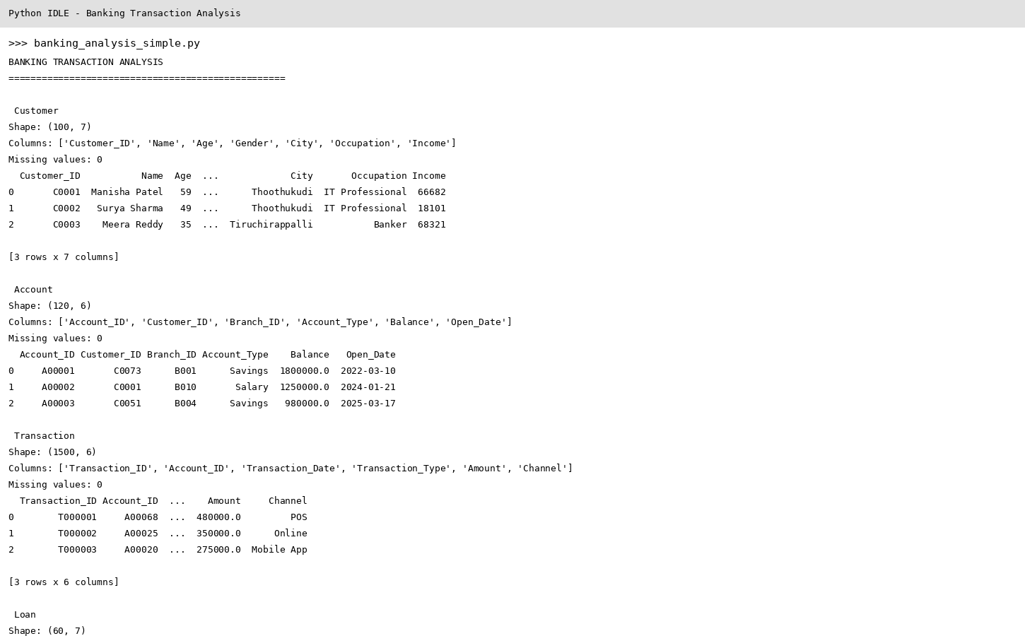
IDLE_Output_01
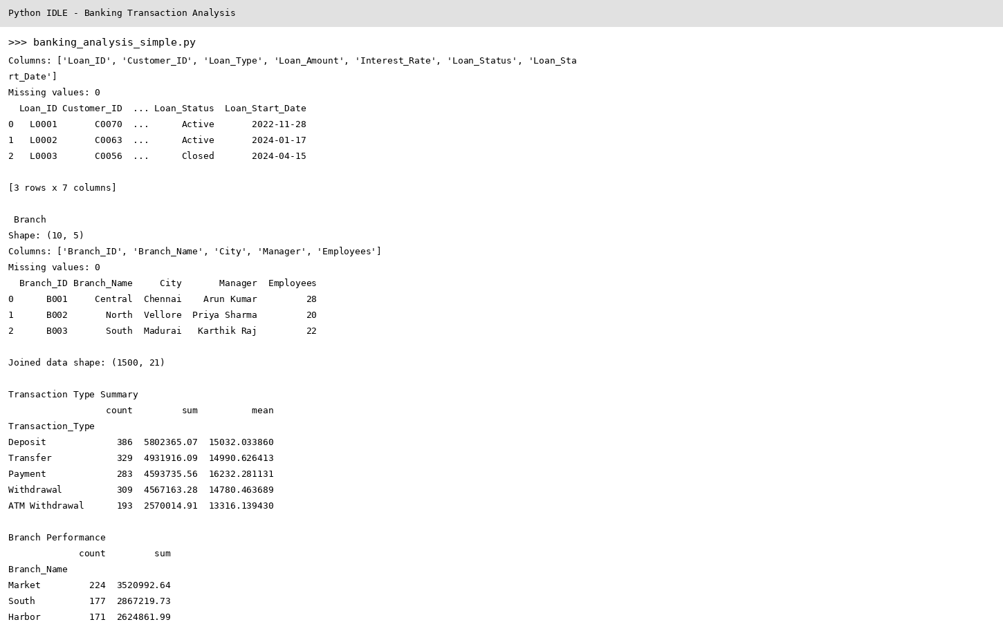
IDLE_Output_02
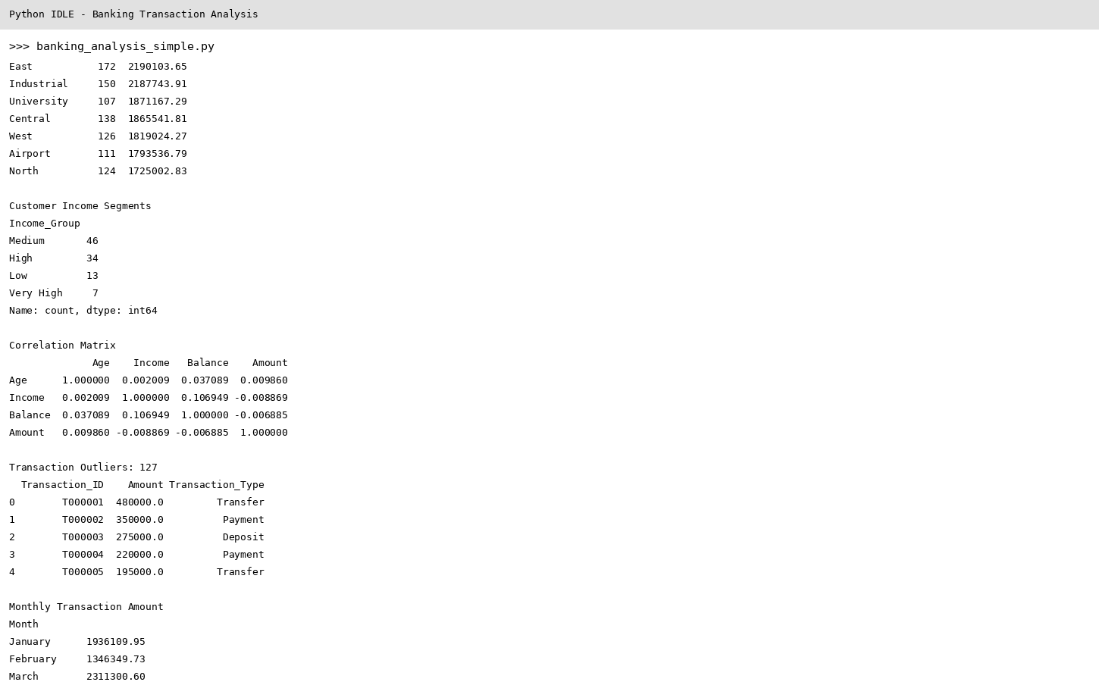
IDLE_Output_03
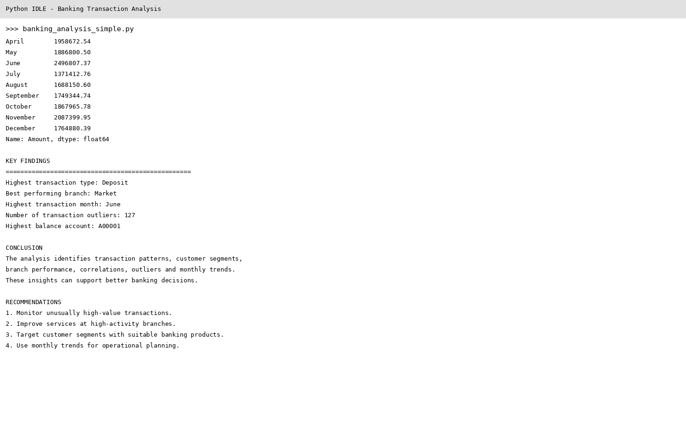
IDLE_Output_04
Output Screenshots – Visualizations

Figure 1: Correlation Heatmap
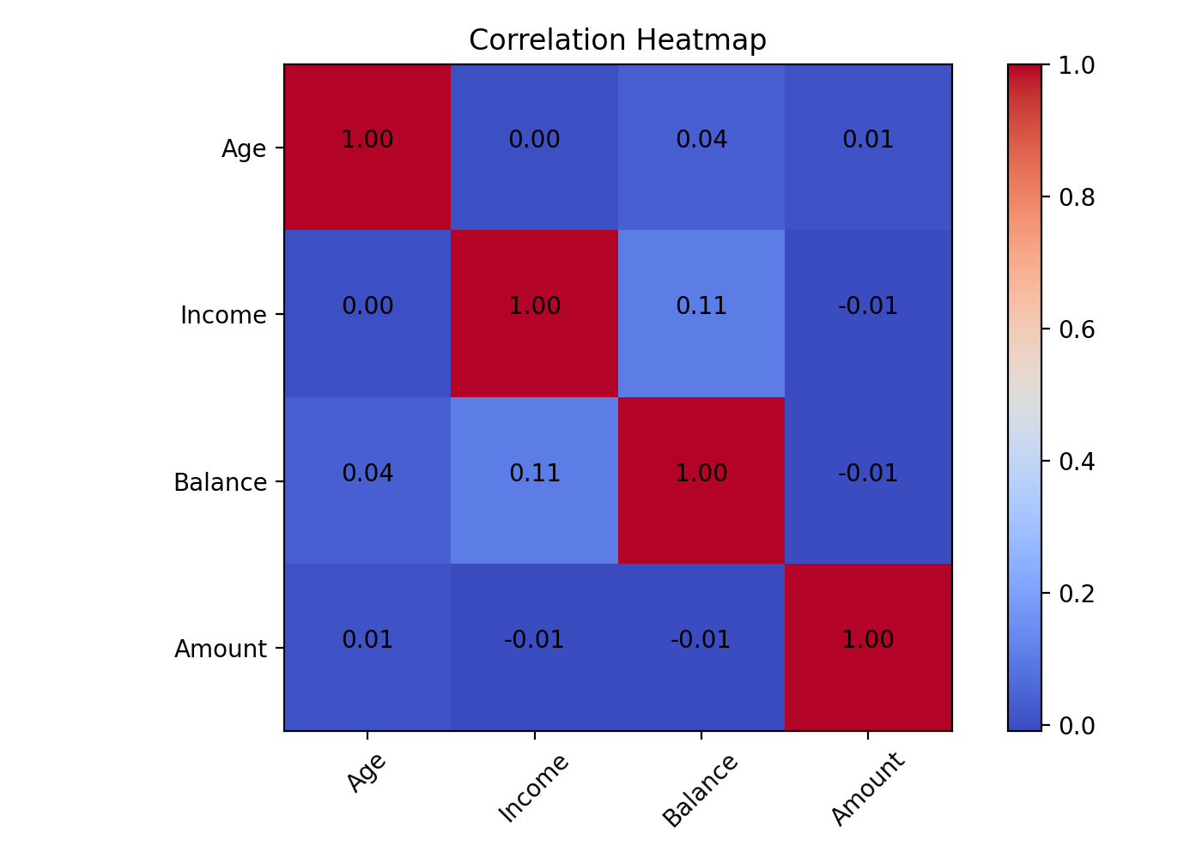
Figure 2: Transaction Outliers
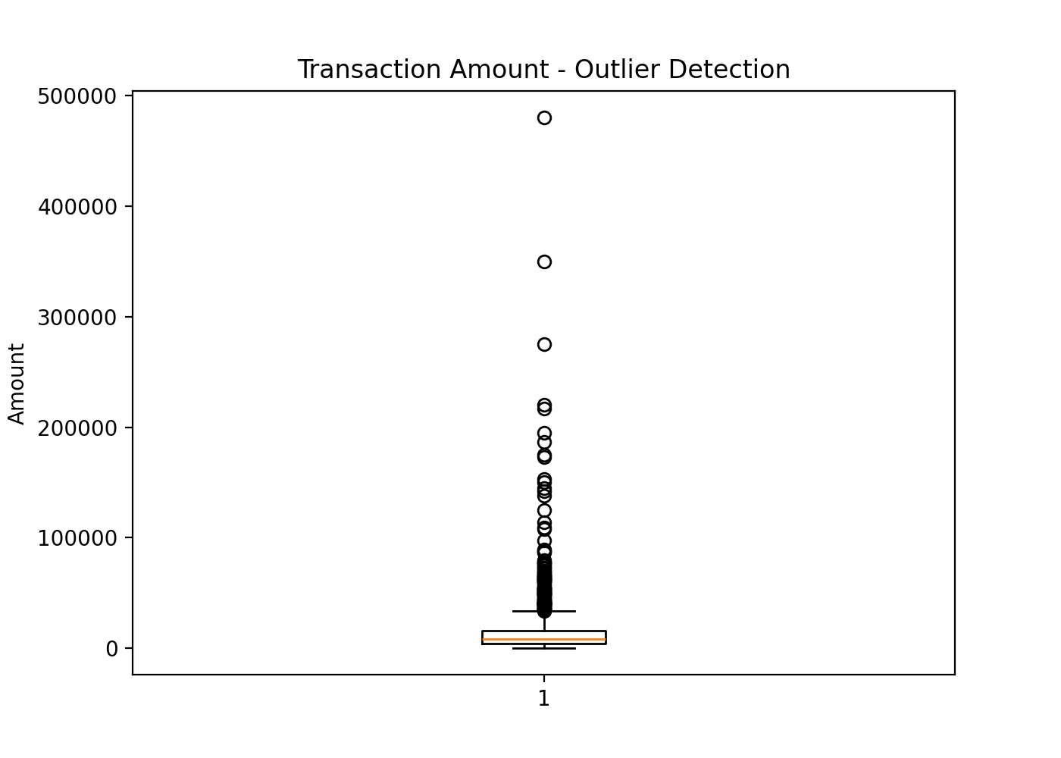
Figure 3: Monthly Trend
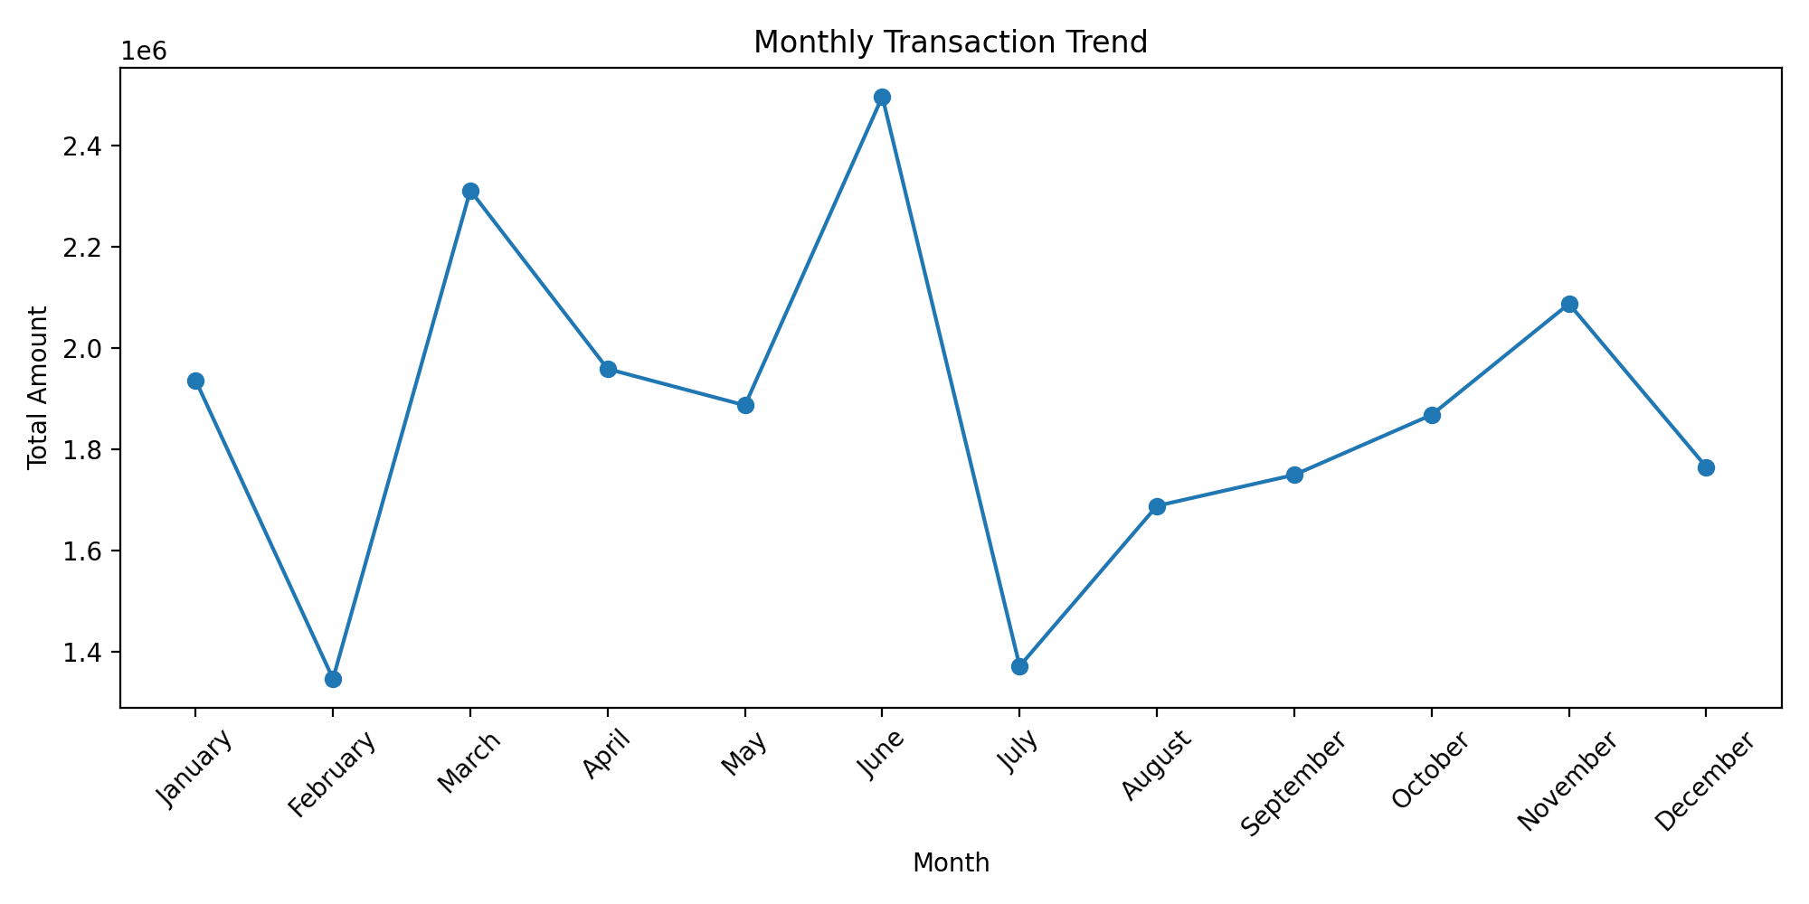
Figure 4: Branch Performance
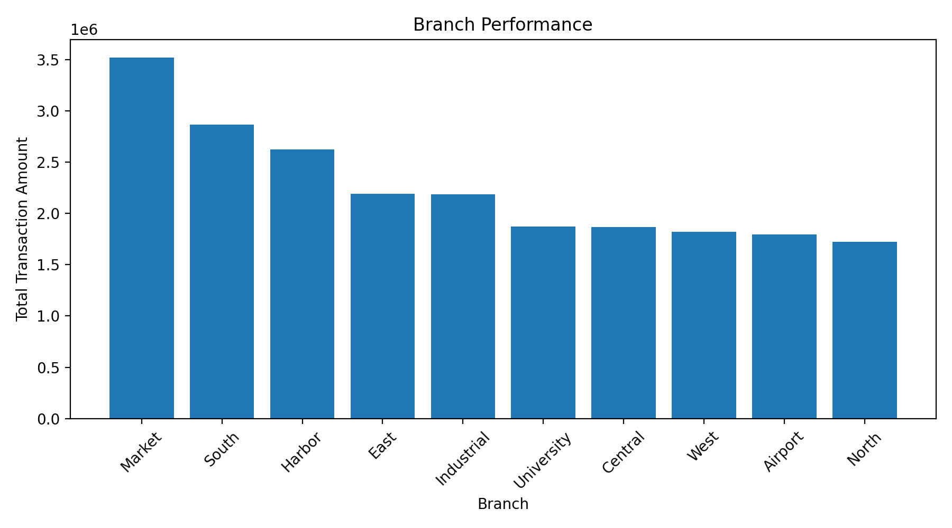

Figure 5: Transaction Type
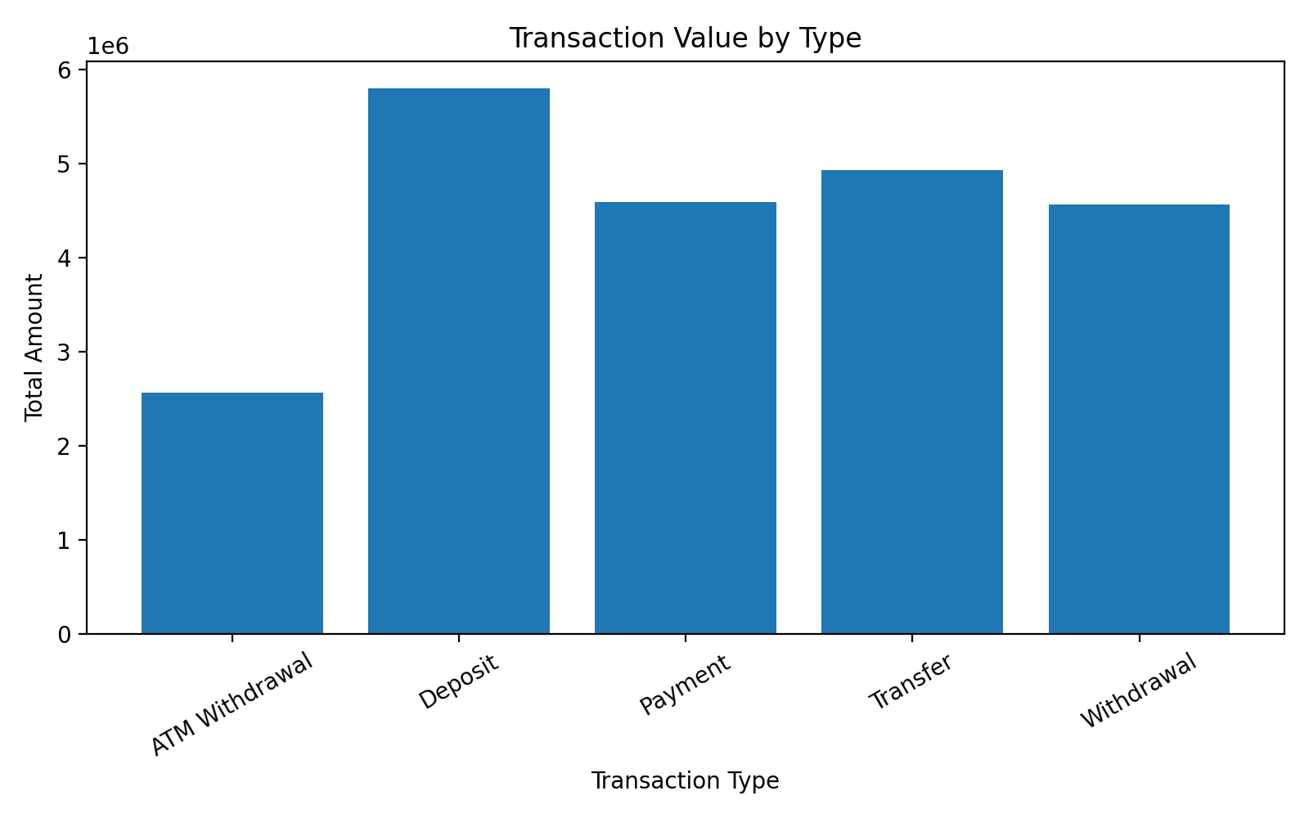
Conclusion
The banking datasets were successfully explored using importing, joining, grouping, segmentation, correlation analysis, outlier detection and monthly trend analysis. The visualizations help identify important transaction and financial patterns.

Question 10 – Social Media Engagement Analysis
A social media platform provides User, Post, Hashtag, Like, Comment, and Share datasets. Analyze user engagement, popular content, hashtags, posting times, and engagement trends. Identify correlations and outliers and create suitable visualizations or an interactive dashboard.
Source Code – Implemented in Python IDLE
This is a short student-level implementation covering all ten mandatory requirements.
import pandas as pd
import numpy as np
import matplotlib.pyplot as plt

# 1. DATA IMPORTING
user = pd.read_csv("User.csv")
post = pd.read_csv("Post.csv")
hashtag = pd.read_csv("Hashtag.csv")
like = pd.read_csv("Like.csv")
comment = pd.read_csv("Comment.csv")
share = pd.read_csv("Share.csv")

print("SOCIAL MEDIA ENGAGEMENT ANALYSIS")
print("=" * 55)

# 2. DATASET DESCRIPTION & EXPLORATION
datasets = {
"User": user,
"Post": post,
"Hashtag": hashtag,
"Like": like,
"Comment": comment,
"Share": share
}
for name, df in datasets.items():
print("\n", name)
print("Shape:", df.shape)
print("Columns:", list(df.columns))
print("Missing values:", df.isnull().sum().sum())
print(df.head(3))

# Convert dates
post["Post_Date"] = pd.to_datetime(post["Post_Date"])
like["Like_Date"] = pd.to_datetime(like["Like_Date"])
comment["Comment_Date"] = pd.to_datetime(comment["Comment_Date"])
share["Share_Date"] = pd.to_datetime(share["Share_Date"])

# 3. JOINING MULTIPLE DATASETS
engagement = post.merge(user, on="User_ID")
like_count = like.groupby("Post_ID").size().rename("Likes")
comment_count = comment.groupby("Post_ID").size().rename("Comments")
share_count = share.groupby("Post_ID").size().rename("Shares")

engagement = engagement.merge(like_count, on="Post_ID", how="left")
engagement = engagement.merge(comment_count, on="Post_ID", how="left")
engagement = engagement.merge(share_count, on="Post_ID", how="left")

engagement[["Likes", "Comments", "Shares"]] = engagement[
["Likes", "Comments", "Shares"]
].fillna(0)

engagement["Engagement"] = (
engagement["Likes"] +
engagement["Comments"] +
engagement["Shares"]
)

print("\nJoined dataset shape:", engagement.shape)

# 4. GROUPING & AGGREGATION
print("\nEngagement by Post Type")
print(engagement.groupby("Post_Type")[
["Likes", "Comments", "Shares", "Engagement"]
].sum().sort_values("Engagement", ascending=False))

print("\nTop 10 Posts")
print(engagement[[
"Post_ID", "Username", "Post_Type", "Views", "Engagement"
]].sort_values("Engagement", ascending=False).head(10))

# Hashtag popularity
hashtag_count = hashtag.groupby("Hashtag")["Post_ID"].count().sort_values(
ascending=False
)

print("\nPopular Hashtags")
print(hashtag_count.head(10))

# 5. DATA SEGMENTATION
user["Follower_Group"] = pd.cut(
user["Follower_Count"],
bins=[0, 1000, 10000, np.inf],
labels=["Low", "Medium", "High"]
)

print("\nUser Follower Segments")
print(user["Follower_Group"].value_counts())

# 6. CORRELATION ANALYSIS
corr = engagement[
["Views", "Likes", "Comments", "Shares", "Engagement"]
].corr()

print("\nCorrelation Matrix")
print(corr)

plt.figure(figsize=(7, 5))
plt.imshow(corr, cmap="coolwarm")
plt.colorbar()
plt.xticks(range(5), corr.columns, rotation=45)
plt.yticks(range(5), corr.columns)

for i in range(5):
for j in range(5):
plt.text(j, i, f"{corr.iloc[i,j]:.2f}", ha="center")

plt.title("Social Media Correlation Heatmap")
plt.tight_layout()
plt.savefig("01_correlation_heatmap.png", dpi=200)
plt.show()

# 7. OUTLIER DETECTION
Q1 = post["Views"].quantile(0.25)
Q3 = post["Views"].quantile(0.75)
IQR = Q3 - Q1
upper = Q3 + 1.5 * IQR

outliers = post[post["Views"] > upper]

print("\nView Outliers:", len(outliers))
print(outliers[["Post_ID", "Views", "Post_Type"]].head())

plt.figure(figsize=(7, 5))
plt.boxplot(post["Views"])
plt.title("Post Views - Outlier Detection")
plt.ylabel("Views")
plt.savefig("02_view_outliers.png", dpi=200)
plt.show()

# 8. TIME-BASED ANALYSIS
post["Month"] = post["Post_Date"].dt.month_name()
monthly = post.groupby("Month")["Post_ID"].count()

months = [
"January", "February", "March", "April", "May", "June",
"July", "August", "September", "October", "November", "December"
]
monthly = monthly.reindex(months).dropna()

print("\nMonthly Posting Trend")
print(monthly)

plt.figure(figsize=(10, 5))
plt.plot(monthly.index, monthly.values, marker="o")
plt.title("Monthly Posting Trend")
plt.xlabel("Month")
plt.ylabel("Number of Posts")
plt.xticks(rotation=45)
plt.tight_layout()
plt.savefig("03_monthly_posting_trend.png", dpi=200)
plt.show()

# 9. VISUALIZATIONS
type_engagement = engagement.groupby("Post_Type")["Engagement"].sum()

plt.figure(figsize=(8, 5))
plt.bar(type_engagement.index, type_engagement.values)
plt.title("Engagement by Post Type")
plt.xlabel("Post Type")
plt.ylabel("Total Engagement")
plt.tight_layout()
plt.savefig("04_post_type_engagement.png", dpi=200)
plt.show()

plt.figure(figsize=(9, 5))
plt.bar(hashtag_count.head(8).index, hashtag_count.head(8).values)
plt.title("Popular Hashtags")
plt.xlabel("Hashtag")
plt.ylabel("Number of Posts")
plt.xticks(rotation=35)
plt.tight_layout()
plt.savefig("05_popular_hashtags.png", dpi=200)
plt.show()

# Posting time analysis
hour_posts = post.groupby("Post_Hour")["Post_ID"].count()

plt.figure(figsize=(10, 5))
plt.plot(hour_posts.index, hour_posts.values, marker="o")
plt.title("Posting Activity by Hour")
plt.xlabel("Hour")
plt.ylabel("Number of Posts")
plt.xticks(range(0, 24, 2))
plt.grid(True)
plt.tight_layout()
plt.savefig("06_posting_time.png", dpi=200)
plt.show()

# 10. KEY FINDINGS
print("\nKEY FINDINGS")
print("=" * 55)
print("Most engaging post type:", type_engagement.idxmax())
print("Most popular hashtag:", hashtag_count.idxmax())
print("Most active posting hour:", hour_posts.idxmax())
print("Number of view outliers:", len(outliers))
print("Highest engagement post:",
engagement.loc[engagement["Engagement"].idxmax(), "Post_ID"])

print("\nCONCLUSION")
print("The analysis identifies user engagement, popular content, hashtags,")
print("posting times, correlations, outliers and engagement trends.")

print("\nRECOMMENDATIONS")
print("1. Focus on content types with high engagement.")
print("2. Use popular hashtags to improve content reach.")
print("3. Schedule posts during active hours.")
print("4. Monitor unusually high views for abnormal activity.")
Output Screenshots – Python IDLE
The output text is displayed in blue to match the requested presentation style.
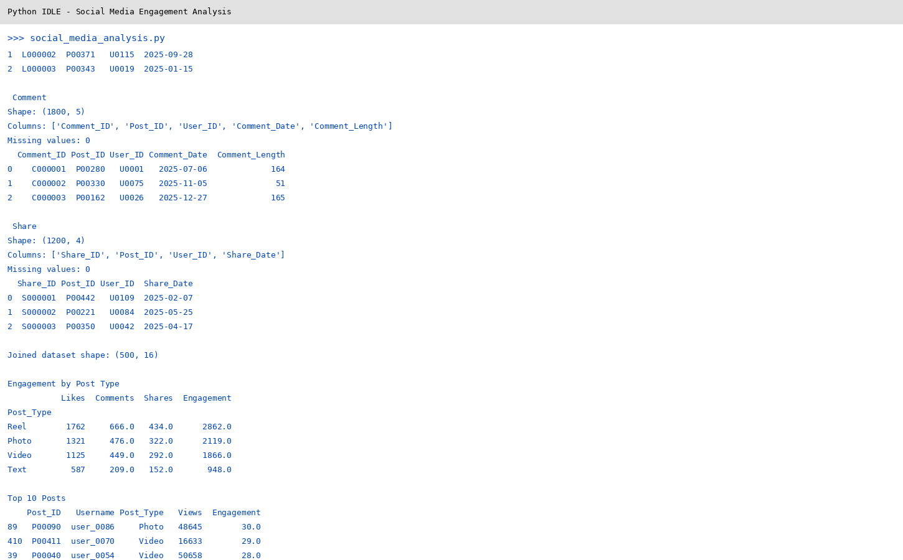

IDLE_Output_02
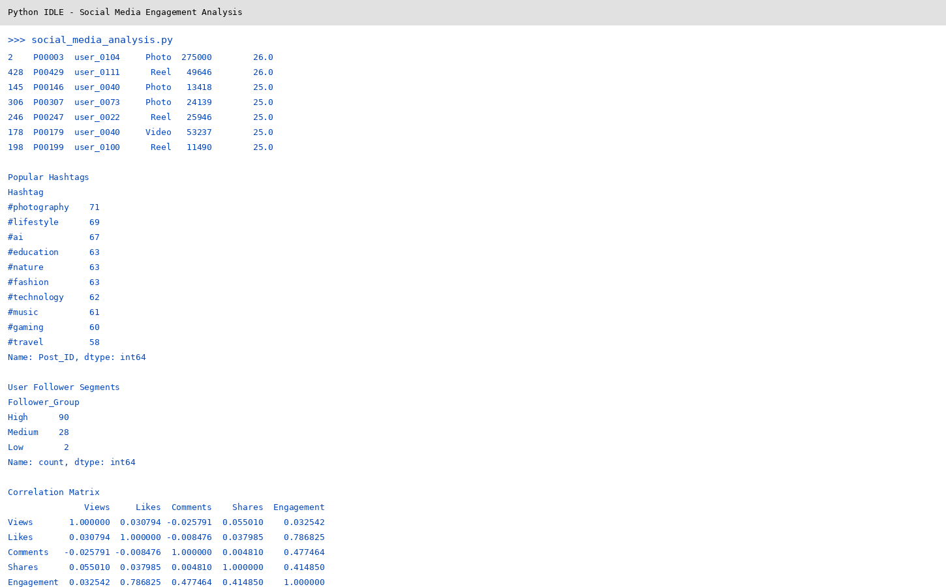
IDLE_Output_03
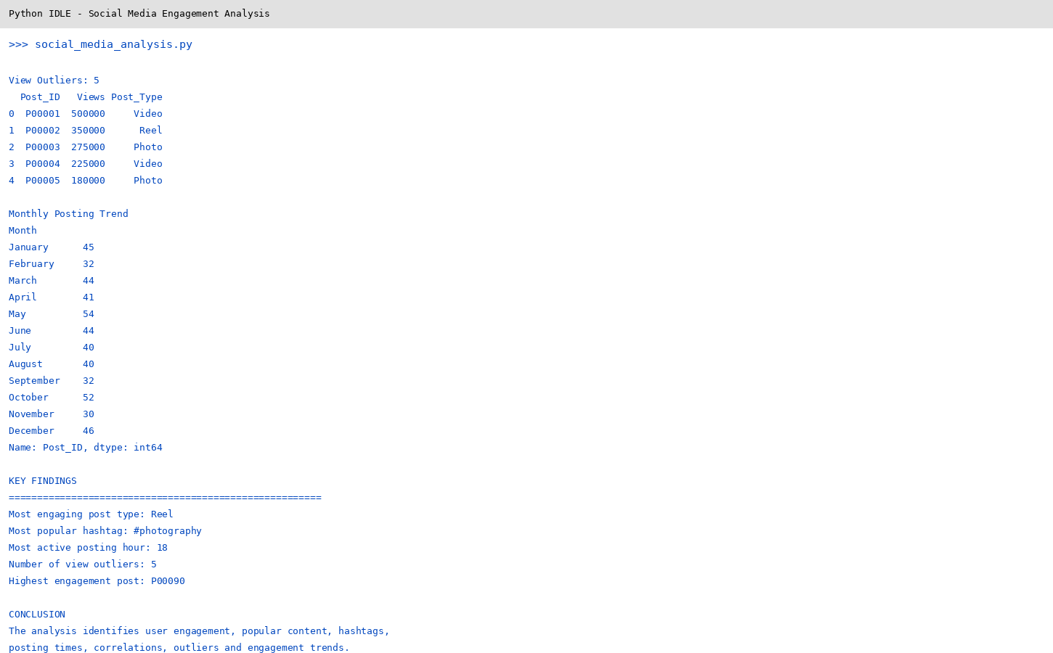
IDLE_Output_04

Output Screenshots – Visualizations

Figure 1: 01 Correlation Heatmap
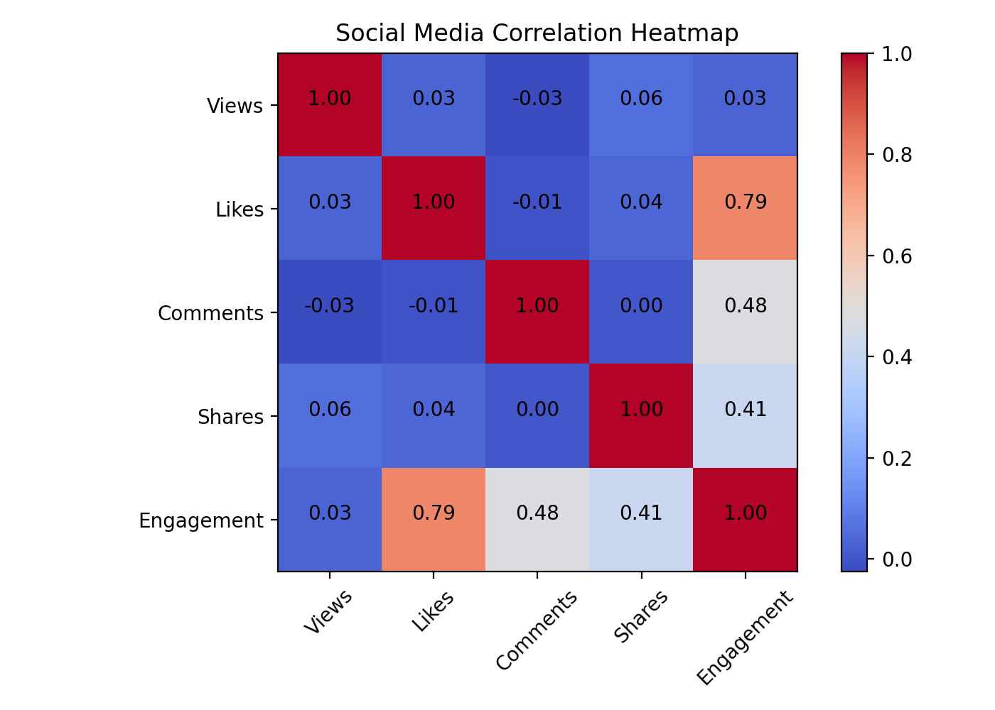
Figure 2: 02 View Outliers
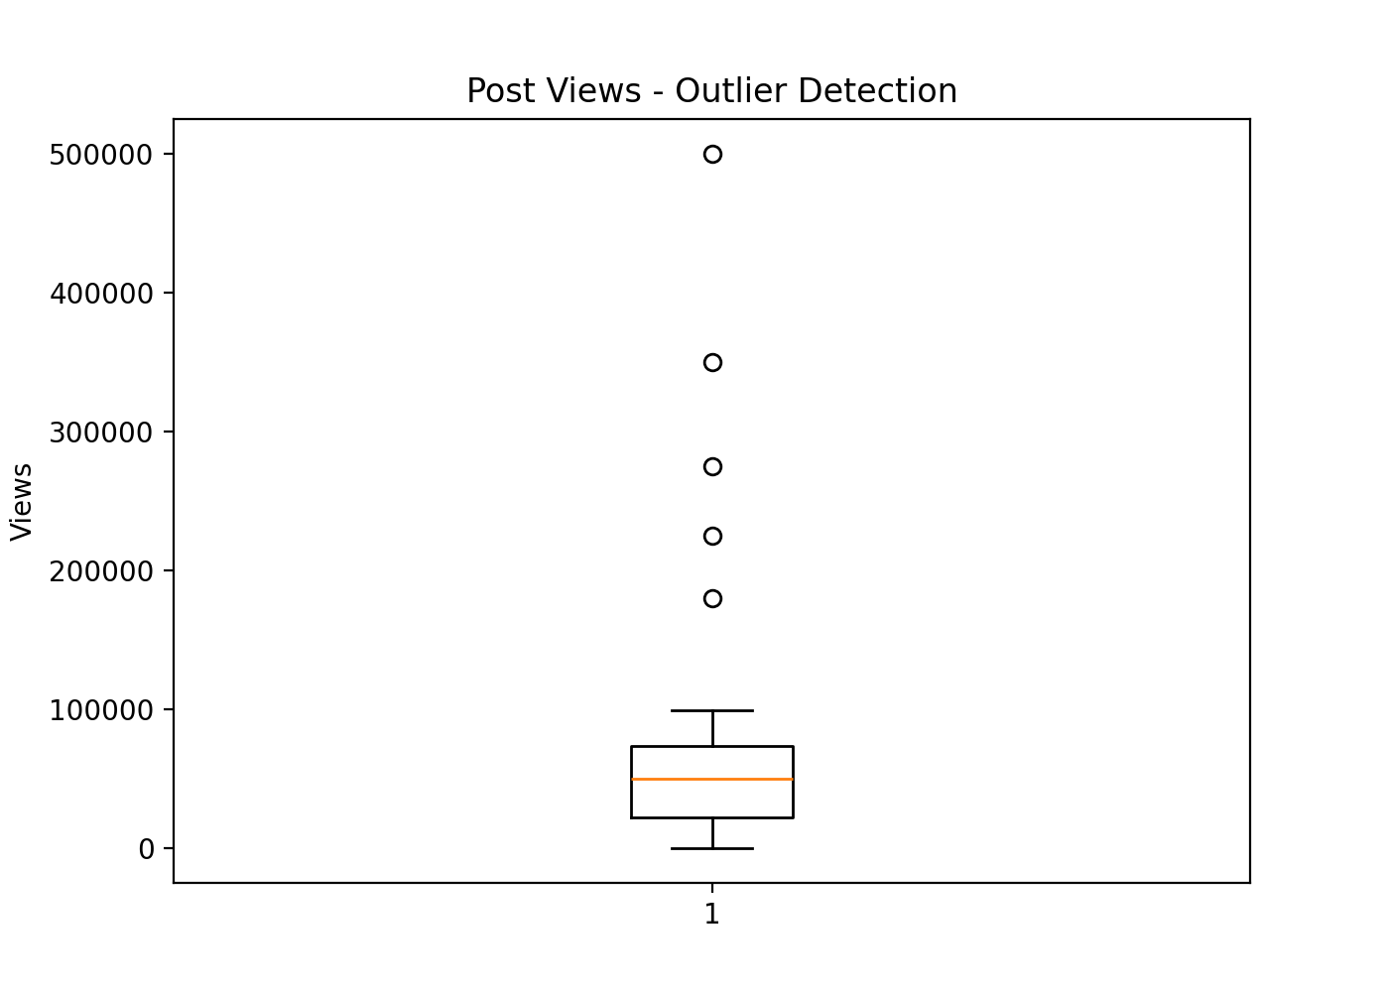
Figure 3: 03 Monthly Posting Trend
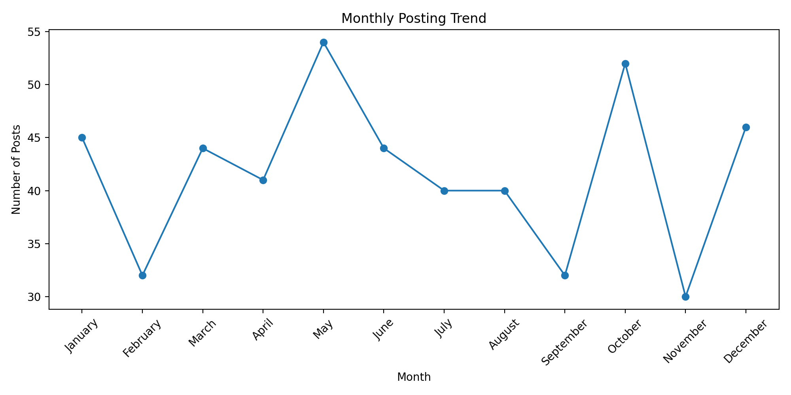
Figure 4: 04 Post Type Engagement
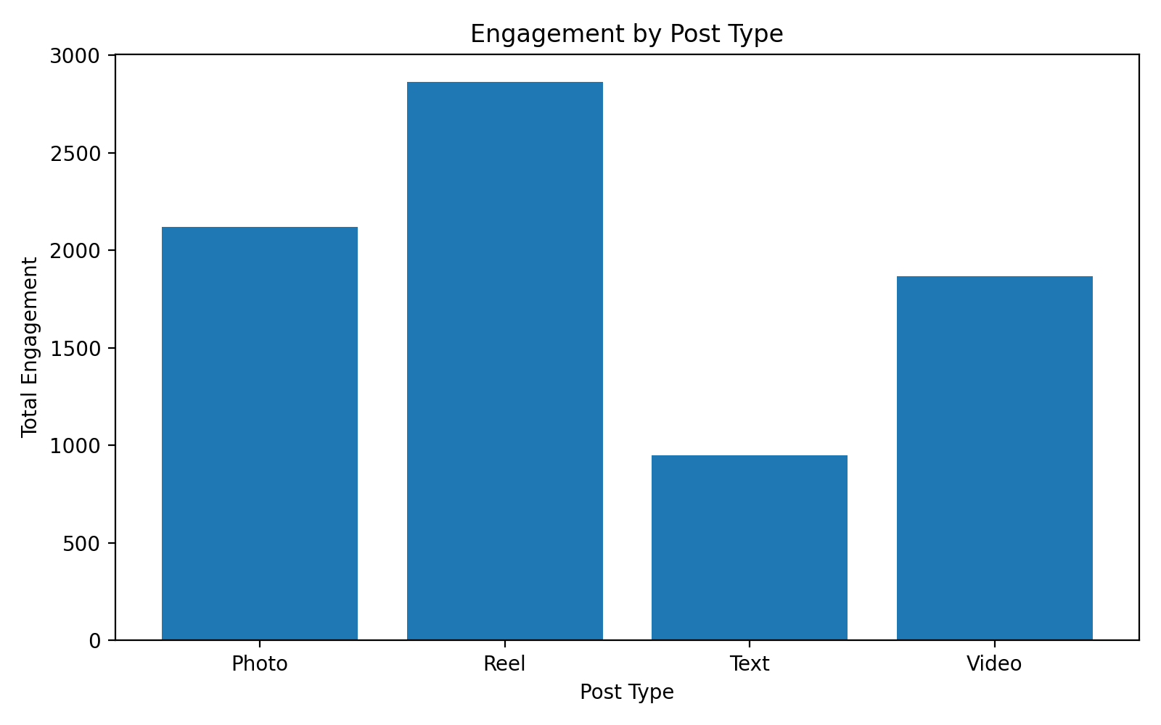
Figure 5: 05 Popular Hashtags
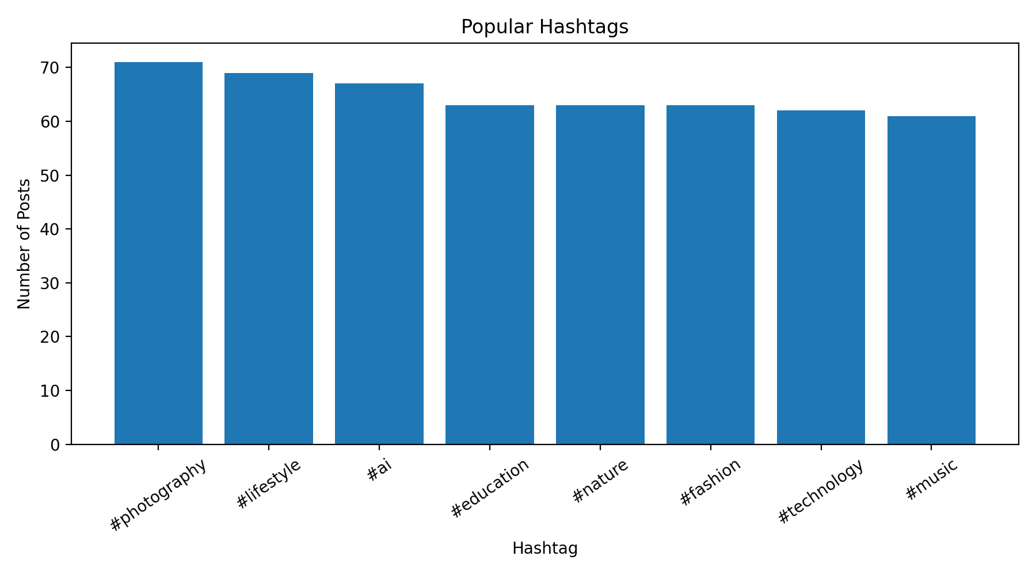
Figure 6: 06 Posting Time
